Basics of Machine learning:
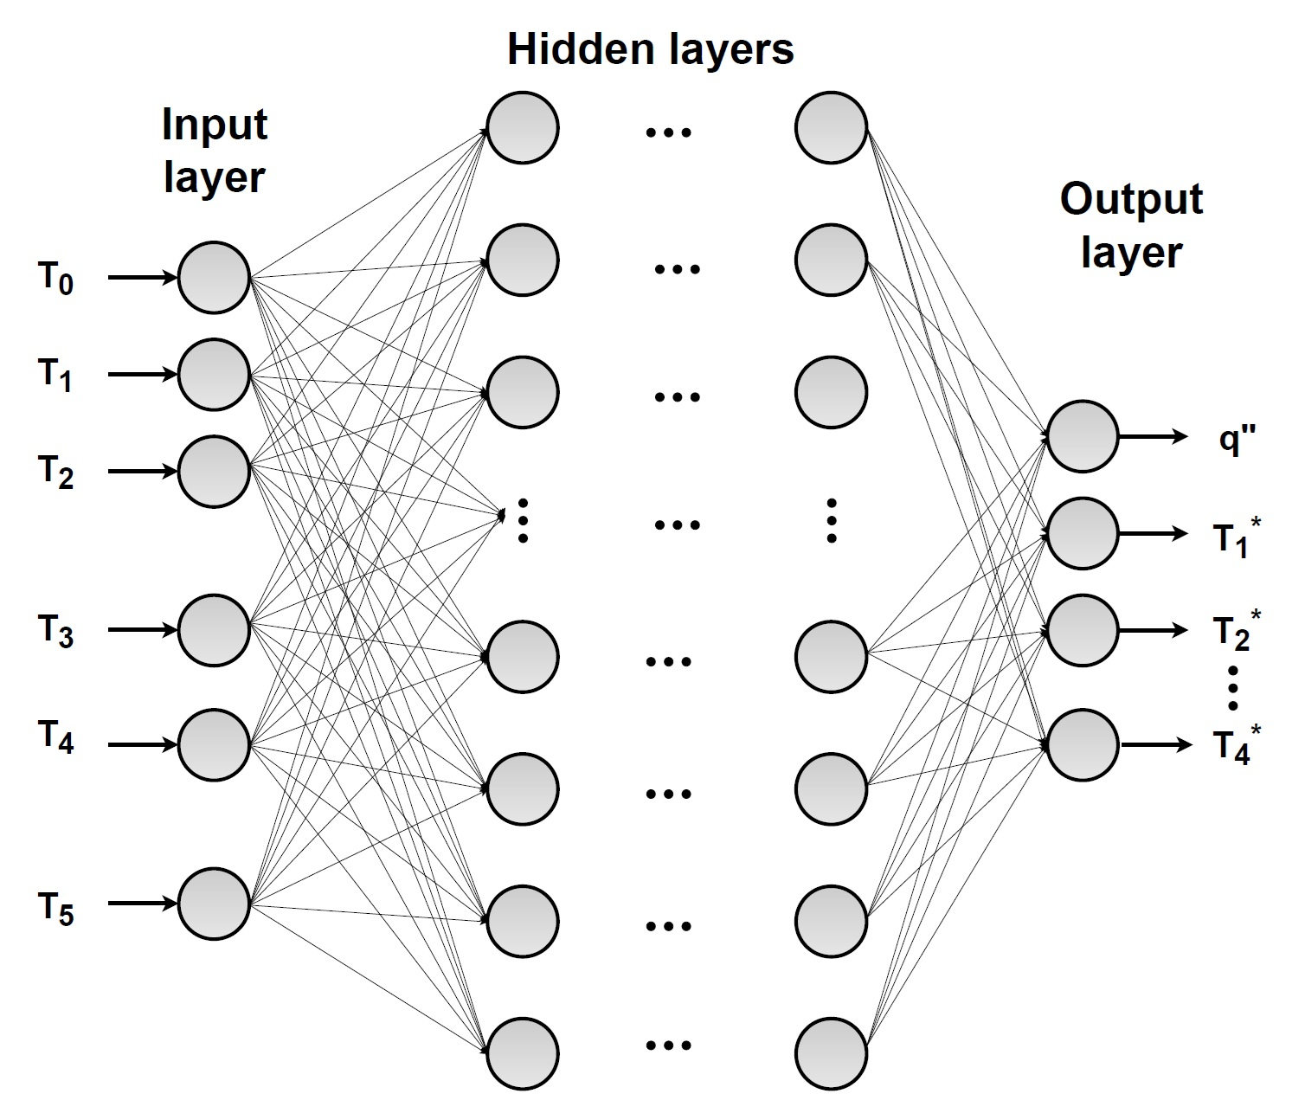
Sample Deep Neural Network
Input Layer
The first layer of a neural network that receives the input data. Each neuron in this layer corresponds to one feature in the input data.
Hidden Layer
The layers between the input and output layers. They process inputs and apply transformations to learn complex patterns.
Output Layer
The final layer of the network that produces the prediction or output.
Training Data
The portion of the dataset used to train the model. It helps the model learn patterns and relationships in the data.
Test Data
A separate portion of the dataset used to evaluate how well the model generalizes to new, unseen data.
Neurons
The basic computational units in a neural network. Each neuron performs a weighted sum of inputs and passes it through an activation function.
Activation Function
A function applied to a neuron’s output to introduce non-linearity. Common examples include:
- Sigmoid:
$$f\left(x\right)= \frac{1}{1+e^{-x}}$$
- ReLU:
$$f\left(x\right)=\max{ \left(0,x\right)}$$
- Tanh:
$$f\left(x\right)=\tanh{(x)}$$
Learning Rate
A small value that determines how much the model’s weights are updated during training. Too high can cause instability; too low can slow learning.
Optimizer
An algorithm used to update weights and minimize error. Common optimizers include SGD, Adam, and RMSprop.
Number of Epochs
The number of complete passes through the training dataset. More epochs can improve learning but may also lead to overfitting.
Training Error
The error calculated on the training dataset. It reflects how well the model has learned from the training data.
Validation Error
The error on a validation dataset used to monitor model performance during training and detect overfitting.
Mean Squared Error (MSE)
A common loss function for regression:
$$MSE= \frac{1}{n} \sum{{(y_{i}-\hat{y_{i}})}^{2}}$$
Mean Absolute Error (MAE)
Another regression loss function:
$$MAE= \frac{1}{n} \sum{\left|y_{i}-\hat{y_{i}}\right|}$$

Applying the Machine Learning in Heat Conduction:
What you already have:
Plate thicknesses (L₁-L₅), material thermal conductivities (k₁-k₅), temperature measurements (T₀-T₅), calculated heat flux (q”) and calculated interface temperatures (T₁*, T₂*, T₃*, T₄*)
What you will be provided with:
A computer with Tensorflow code using python libraries via Github and Importantly the dataset from the experiment in CSV file format.
What you will execute:
- Run the code
- Plot the following charts:
- MSE vs Epoch
- MAE vs Epoch
- Predictions vs test values
- Error Distribution for q”, T₁*, T₂*, T₃*, T₄*
Steps:

- Understand your data, what are the inputs and what are the outputs. Avoid fixed parameters like thermal conductivities, thermal resistances and plate thicknesses.
  - Inputs: temperature measurements (T₀-T₅)
  - Outputs: temperature measurements q”, T₁*, T₂*, T₃*, T₄*
- Upload the data:
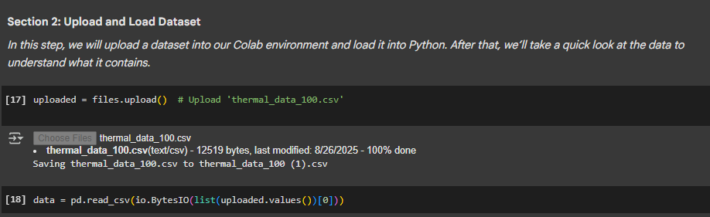
- Differentiate the inputs and outputs from the uploaded CSV file:
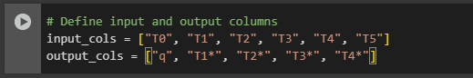
- Split your data into training and testing sets:
    - Use 80% for training the ML model.
    - Use 20% for testing/validation.
(You may also try 85-15%, etc., and compare results.)

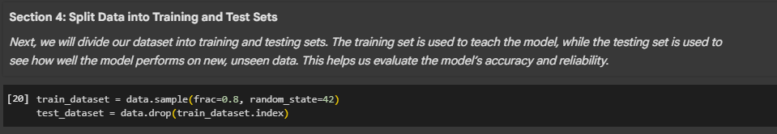

- Prepare your data for Machine Learning:
Normalize your data (scale input features so they have similar ranges, e.g., between 0 and 1).

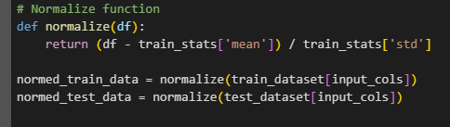

- Build a Simple Neural Network Model in TensorFlow
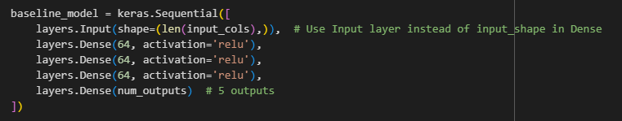

You can see in the above screenshot that we have three hidden layers with each layer having 64 neurons with ‘relu’ as the activation function. You may change the architecture based on your choices.
- Compile the model
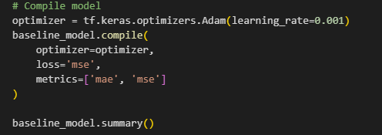
- Train the model
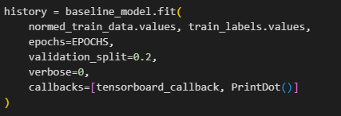
- Plot the MSE and MAE metrics with respect to epochs:
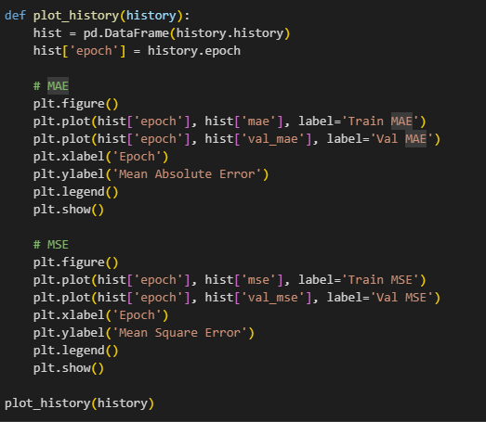
- Plot remaining graphs of predictions vs test values and error distribution.

